There will be a memorial for David R. McEachren
December 26th at 2:00 PM
at the Salcha Senior Center just off Johnson Road in Salcha,
Pot luck dinner, please bring a side dish.
Also, any picture or Stories, Dave always had a good Story.

The seniors are having a Salcha senior membership drive.
We are inviting everyone to join 18+. We need men and women of all ages. It is great to have people with a lot of ambition, drive and great ideas. PLEASE PASS THE WORD ON TO OTHERS and have them call me at 488-5802. We have lots of fun at our meetings. So please come and join us at our next meeting on Saturday Nov 7 at noon. Bring snack to share and we have free Bingo that day. You don't have to live in Salcha to join. Please come and share your ideas on Nov 7

Borough Assembly Meeting this Thursday, December 10, 2009 from 6-7:00pm.to testify on items not on the agenda. This is your opportunity to testify on Grandfather Rights and General Use Zoning. Let the Assembly know that you feel strongly about your individual private property rights.

Department of Forestry
meeting at the
Salcha Seniors Dec 10th 6:00 pm
Reduce wood/fire fuel between Salcha River and Harding Lake.

Meeting for the Transportation Board at Borough Building Dec.2nd 6:00 PM Chizmar room. Public input on Shuttle bus for Salcha.

***LOST DOGS***
Missing from Frostbite Court
1 small white female sled dog, answers to "Trigger"
1 small black and tan male sled dog answers to "Action"
friendly dogs, contact Gary Dunlap 799-8601 if found
thank you

Salcha School Nov. 10th 6-7 PM
GRANDFATHER RIGHTS
ORDINANCE NO. 2009-26
AN ORDINANCE AMENDING TITLE 18 OF THE FAIRBANKS NORTH STAR BOROUGH CODE OF ORDINANCES AS IT RELATES TO NONCONFORMING BUILDINGS, STRUCTURES, USES AND LOTS AND ADDING PROCEDURES FOR NONCONFORMING STATUS DETERMINATIONS AND APPEALS
Full Text 2009-26

Salcha Fire Service Area Meeting
9 Nov 09 (Monday)
1900 (7pm)
Salcha Senior's Center

Salcha's Neighborly Org.--SNO wants to invite all of our neighbors to join us for a community Halloween Party including a costume contest with homemade candies and treats--at SNO-- 8768 Richardson Highway after 5 pm. FREE

Wednesday October, 21 / 6 pm @ Salcha Seniors / Rural Transit Meeting
Link to printable petition

The McDonald House Corporation thanks all group and individual efforts in collecting the "POP TABS" which benefit families during their child's hospital stay away from home. Dale Rankin is the point of contact: to drop off or mail tabs see him in suite #209 or call 456-4339 at the Arctic Bowl Building at 950 Cowles Street, Suite #209, Fairbanks, AK 99701. Thanks again for helping your community to help others. | 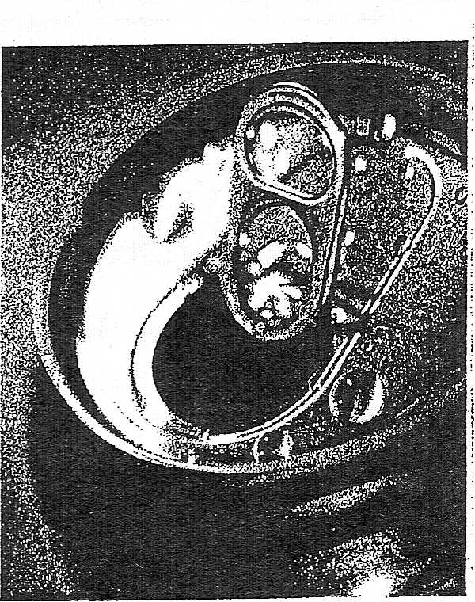  907-456-4339

As of October the Salcha seniors are changing their meetings to the first Sat. of the month for the winter. The first one is Oct 3 at noon. Bring a snack to share and after our short meeting we are playing a few bingo games at no cost to you. So please come and join the board and members for a fun day.
Our Fall bingo/ dinner is Oct 17 with our Fried chicken dinner ($6) starting at 5pm and bingo ($12.50) starting at 6pm. Come join the fun. Any questions call me at 488-5802.

NOTICE OF MEETING:
DENALI-THE ALASKA GAS PIPELINE will be in Salcha at 7:00 pm
Monday, September 28, 2009 at the Salcha Community Office( SNO Building). Come learn about the project, ask questions, and provide us input! This is an informational meeting for communities within the proposed gas pipeline corridor. The agenda will include information about work completed for the proposed gas pipeline and plans for proposed work.
www.denalipipeline.com
Lisa Pekich
Outreach Supervisor - Alaska
Denali - the Alaska Gas Pipeline
(907)865-4710 (office)
(907)229-9182 (cell)
Lisa.Pekich@denalipipeline.com

Seniors Fall Prevention week

SNO's Grand Opening
September 18th from 7:00 p.m.
Enjoy a neighborly potluck,
neighborly jam session and neighborly dance.
Also, participate in SNO's first play day,
Saturday September 19th from noon-8:00 p.m.
with a tournament of games
(including but not limited to pool,
horse-shoes, darts and WII)
Approximately mile 324.5 Richardson HWY,
south end of Munson Slough Road
And this keeps getting better,the Bookmobile will be
open for business at the Community Center for 1.5 hours this coming Saturday.
If not this Saturday, the Bookmobile will head your way the third Saturday of
the month from October 17th forward for at least a year. This will reintroduce
Borough library services to Salchans - and help us gauge community interest in
having a local library.

SNO Yard Sale
Mile 324.5 Richardson Highway
Working towards getting insurance money to open building

Alaska's 50th Anniversary Quilt
on display the entire month of August at Pioneer Park in the Bear Gallery in the Civic Center 12-6PM
See panels

The 2009 Deltana Fair
July 31 - 10 am to 10 pm
August 1 - 8 am to 10 pm
August 2 - 8 am to 5 pm
WEBSITE

The borough assembly will be considering a resolution to approve a Memorandum of Understanding between the Alaska Department of Environmental Conservation and the Fairbanks North Star Borough for Air Pollution Control at this Thursday’s regular assembly meeting. This M.O.U. has been available to the public for less than two weeks. It is a 15 page document that appears to commit the borough to accepting significant new responsibilities for air quality monitoring and regulation of emission sources including solid fuel burning devices such as wood stoves.
This memorandum could place us on a path to implementing another expensive and intrusive air quality program similar to the IM program that we have endured for the past 20 years. The MOU is purposely vague, it isn’t even clear whether the IM program will be eliminated as the administration has intimated, it could also include restrictions on using wood to heat our homes and other drastic requirements to solve a problem that is primarily the result of local climatic conditions! The vagueness of the memo is itself a problem that must be resolved.
The assembly should move to postpone voting on this resolution until the public has had adequate time to review the document and understand exactly what they are proposing to do. Unfortunately, the current assembly has a poor record of exercising their responsibility to diligently review what the administration proposes to them and has instead pretty much simply taken what ever the administration hands to them. Because this is a resolution, the assembly hasn’t even scheduled a public hearing for it. They probably will just pass the resolution unless there is a public outcry to do otherwise.
Therefore, is vitally important for you to let the assembly members them know that you are concerned about the implications of this Memorandum of Understanding and ask them to postpone action on the resolution approving it until such time as the public has had adequate opportunity to review and comment on it.
You should at the very least send an email to the assembly to ask them to postpone action on the resolution until the public has had time to review and comment on it. The merits of the proposal can be debated later, but we need time to have the debate. This is the assembly’s email address: assembly@co.fairbanks.ak.us . Click on the link and send them a short message right now.
You should also make it a priority to attend this Thursday’s assembly meeting at 6:00 to demonstrate your concern. There is no point in complaining about the result six months from now if you didn’t take advantage of the opportunity to make your voice heard at the appropriate time. (Which is this Thursday.)
If you do attend, please wear a navy blue shirt to demonstrate our unity of purpose. There might only be a few minutes allotted for testimony, so a visual message might be our only opportunity. This is also why we want to focus on postponement rather than the merits of the proposal.
This is a link to the assembly agenda for those who want to review the resolution and memorandum before commenting: ftp://co.fairbanks.ak.us/Assembly%20Agenda%20Packets/RegularPackets/2009/07-16-09.pdf
You can also find it on the borough’s website under the ‘assembly’ link on the home page. (The memorandum starts on page 109 of the agenda.)
This resolution is important to all borough residents regard less of whether you heat your home with wood.

2009 Salcha Fair
June 26, 27 & 28
2009 Salcha Fair Flyer

POTLUCK and DESSERT AUCTION
To support Interior Right to Life, 6 PM SATURDAY JUNE 20th at Northern Lights Church of Christ, 645 11th Avenue, next to Yukon Title. If your last name starts with A-M, please bring a main dish, N-Z, please bring a side dish. If you want to bring a dessert for the auction, contact Ben Mitchell at 455-6718 or at icebreaker@emypeople.net. This is a fun event to help a good organization that is struggling financially right now. Please bring a dessert and some friends and make this event a success.
Schaeffer Cox, President, Interior Right to Life

Think about this for a minute. Sound familiar?
It is the month of August; a resort town sits next to the shores of a lake. It is raining, and the little town looks totally deserted. It is tough times, everybody is in debt, and everybody lives on credit.
Suddenly, a rich tourist comes to town.
He enters the only hotel, lays a 100 dollar bill on the reception counter, and goes to inspect the rooms upstairs in order to pick one.
The hotel proprietor takes the 100 dollar bill and runs to pay his debt to the butcher.
The Butcher takes the 100 dollar bill, and runs to pay his debt to the pig raiser.
The pig raiser takes the 100 dollar bill, and runs to pay his debt to the supplier of his feed and fuel.
The supplier of feed and fuel takes the 100 dollar bill and runs to pay his debt to the town's prostitute that in these hard times, gave her "services" on credit.
The hooker runs to the hotel, and pays off her debt with the 100 dollar bill to the hotel proprietor to pay for the rooms that she rented when she brought her clients there.
The hotel proprietor then lays the 100 dollar bill back on the counter so that the rich tourist will not suspect anything.
At that moment, the rich tourist comes down after inspecting the rooms, and takes his 100 dollar bill, after saying that he did not like any of the rooms, and leaves town.
No one earned anything. However, the whole town is now without debt, and looks to the future with a lot of optimism.
And that, ladies and gentlemen, is how the United States Government is doing business today.
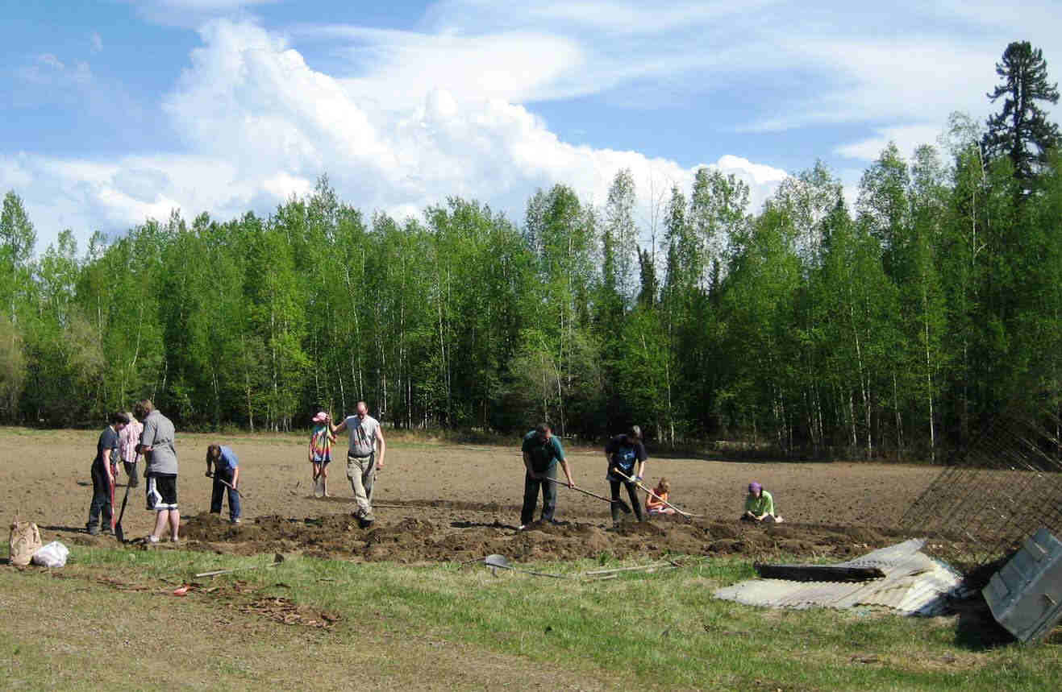 | Day one of planting at the Salcha Community garden, Potatoes, carrots, onions and Margie's Menagerie (a bunch of seeds that got mixed up.) We still have some beets and turnips to put in and a lot of room left for others that would like to get a plot going. Contact Morrie @ 488-7114
SALCHA COMMUNITY FLEA MARKET/SILENT AUCTION
Thursday thru Sunday, June 4-7
The Salcha seniors are having a flea Market and silent auction at the senior building off of Johnson Road. There will be food like Indian Tacos, hot dogs, chips, popcorn and soda. Other vendors will be there. Starts at 8am and goes until 6pm. There will also be a 50/50 and the drawing for the silent auction and 50/50 will be on Sunday the 7th. We are raising money to buy supplies for our soldiers in Iraq and Afghanistan. We are collecting items for our garage sale and silent auction.
Call 488-5802, Rhonda for more information.

Salcha Teen get together
Saturday May 23rd @ 7 pm
in the Green Building at the South end of Munson Slough Road where it meets back up with the Richardson. That is between the elementary school and the river.

SALCHA COMMUNITY FLEA MART
Thursday thru Sunday, June 4-7
The Salcha seniors are putting on a community flea mart. This is to get the community together, meet new friends and sell their items. There will be garage sale items, craft items, food, games, swap stuff, Tupperware, candles, Alaska made stuff and more.
The seniors are fixing Indian Tacos and coffee. They are collecting items for their garage sale from anyone who doesn’t want to have a sale of their own.
The Girl Scout Troop #237 is selling hotdogs, soda and popcorn. They are also selling Tupperware.
For more information you can call Phyllis @ 488-1664, Sharon @ 488-2512, Carolyn @ 488-5790 or Rhonda @ 488-5802.
This will be so much fun so call us soon. Remember, the seniors are collecting stuff for their sale so clean out your shed, garage and house and donate. Thank you, the Salcha Seniors.

Community Message for Well Users:
Due to the publicity of Article printed in News Miner that came out Jan. 18th about Water for Salcha and sometimes we go without a bath? The DEC drinking water program contacted us and said that if we have more than 25 people a day that uses the well water (Their example is: 1 person who gets water and then takes home to a family of 4 that constitutes 5 in your daily count) and they require documentation, than we need to be a certified community well. To be compliant with that it would cost us Thousands of dollars that we don’t have. Therefore we will be putting a lock on the well. We were advised that we could have limited access. We will continue to ask for well donations of $40.00 a year for membership and we will give you a key. That will give us the documentation of use that is required by the DEC. Note: If you have a problem with the well please contact us instead of taking a sledgehammer to the faucet and causing the water to flow freely and glacier up so that no one else can use it. We also had to have the pump rebuilt last winter because it burned out. (Thank you Gary Johnson). This costs the fair money to replace it. In the past the most we have raised for a yearly donation on the well is $350.00 that does not cover the yearly expense to keep the electric on and cover vandalism and repairs. Please remember we are all volunteers on the board and the fair gets its money from donations and sponsorships and whatever we can make with our annual fair. This is a major job for a volunteer to make sure there are funds in the account to cover operating expenses. For those individuals who cannot afford to help us in this endeavor of keeping the electric on and you don’t have running water and need the water please contact us at salchafair@alaska.net or call Lori @ 488-0803 or Peggy @ 488-4556 and we will make sure you get a key. Thank You and please join us in celebrating our community fair.

Health Fair
Salcha School
Saturday May 2, 2009
8:00 AM to 1:00 PM

Public notice
Salcha's Neighborly Organization's Relationship to Interior Seniors Citizens of Salcha, Alaska, INC.
In the December 2008 Summary (read here) mention was made that "cooperation and promises from the FNSB Land Management, FNSB Public Transit, Alaska Interior Public Library System, Fairbanks Food Banks, Fairbanks Resource Agency, UAF Cooperative Extension, Adult Education & Outreach Program, Valley Community for Recycling Solutions, Commission on Historical Preservation, Local & State Representatives, Salcha Seniors, and many local Salchans."
So in response to the Board of Directors request (read here) The limitation of SNO'S relationship to the Salcha Seniors is the rental of their hall.
Please disregard any previous references till I can get them cleaned out.

Senior luncheon Sat. April 24
1:00 PM @ the Salcha Senior Center
Ham will be served

A meet will be held on Wednesday April 22nd at 7:00 - 8:00 PM to discuss the development of some community gardens here in Salcha.
It will be held at the Markgraf family home (the old Salcha Sports shop) located on the Richardson Highway at the south end of Munson Slough Road, approximately mile marker 322.5 Richardson HWY
If you are interested, please attend, for more info, call Morrie at 488-7114

Seniors Bingo
On Sat. April 18 the Salcha seniors are having a Dinner/Bingo again. Spaghetti dinner at 5pm and Bingo at 6pm. Come join the fun. Call me at 488-5802 for more information. Let family, friends and co-worker know. See you there. Mark your calendars.

The Salcha Fair Association proudly hosts Community Easter Egg Hunt Saturday April 11th. Held on the Salcha Fairgrounds Starts Promptly at 12:00 Noon Grades 6 and under Hot dogs, chips and fruit drink provided Special Thanks to our Community Sponsors Salcha Store and Service, Midway Lodge, Salchaket Roadhouse, Rolling Stone Inc. Wal-Mart, Safeway’s Bentley Mall, University and North Pole, Also Fred Meyer East and West Thank you Lori Lovan for all your hard work in preparing for event. Need volunteers to help hide eggs! Please call Lori @ 488-0803 or Peggy @ 488-4556

SALCHANS
Join your neighbors in celebrating the winter thaw!
Salcha’s Neighborly Organization is sponsoring
SNO’s Spring Soiree
Dance to our own local musicians.
Share a dish at the potluck.
The first day of Spring: March 21st 6-9 p.m. @ the Salcha Seniors Building
For more information or to volunteer call:
Melissa @ 488-6420 or melissa@salcha.org

The Tenth Amendment is not all that hard to understand:
"The powers not delegated to the United States by the Constitution, nor prohibited by it to the States, are reserved to the States respectively, or to the people."
Alaska House Resolution 9
So far Alaska is one of 30 states adopting state sovereignty to limit federal powers over their state and we the people therein.

What is in the works
Relay for Life - forming teams now, contact Deb @ 490-5999
Mr. Jerry Boehlke has donated the use a piece of land for a community garden, more details to follow.
SNO will be working on getting a blood drive together, possible CPR and First Aid Training to.
For more discussion, see those topics on the Salcha Message Board
SNO is getting a building to work out of till we can get a community structure built, we are looking for volunteers to help with fixing up the building, cleaning, painting and carpentry skills a plus.
Also, a desire to have fun and enjoy your neighbors. A smile and a sense of humor optional!

Campaign For Liberty

2nd Amendment Task Force

This Thursday, March 5th, 7 PM at Friend's Church (1485 30th Ave Fairbanks) we will have a panel of state and federal officials (State Troopers, National Guard, FPD, and ATF) answering questions about the 2nd amendment and further infringements. Any
questions, call Schaeffer Cox 590-9903

Therriault Resolution Calls on Congress to
Reject HR 45 - Firearm Licensure Bill

Second Amendment Task Force
Monday Night
Friends Church on 30th Ave
7 pm Feb. 16, 2009
Spread the Word

PUBLIC INPUT TILL FEB. 2, 2009
Link to Surface Transportation Board (STB) concerning Salcha and the Northern Rail Extension to Greely. Follow the LINK on this page for public feedback. Closing Date for public comment is Feb. 2, 2009 Click here -> LINK <- To STB

Salcha Fire Service Area Community Meeting
Salcha Fire and Rescue have a meeting planned for Jan 30, Friday at 7 pm at the Salcha Elem School. We are sending out petitions this week to try to form a Fire Service Area in Salcha.
Please plan to attend the meeting to show support for a service fire area in Salcha. We will try to answer your questions and hear your concerns. There will be petitions going out this weekend, early next week to residents in the proposed service fire area.
Any questions, please contact Deb Skotnicki 490-5999

THERE WILL BE A FUNDRAISER THIS SATURDAY JAN. 24th FOR ROBB HOWARD.
HIS HOUSE BURNT DOWN IN SALCHA AND MONEY IS BEING RAISED TO GET HIM BACK ON HIS FEET AND REBUILD HIS HOME.
IT WILL BE AT THE SALCHA SENIOR BUILDING OFF OF JOHNSON RD AND STARTS AT 1:00. THERE WILL BE A DINNER SERVED FOR $5 PER PERSON PER SERVING.
THE DINNER IS LASAGNA, SALAD, GARLIC BREAD AND COFFEE. SODAS AND BOTTLED WATER.
THERE WILL ALSO BE A RAFFLE AND 50/50 RAFFLE
THEY ARE ACCEPTING DONATED ITEM TO RAFFLE OFF. THEY WILL NEED TO BE DELIVERED OR PICKED UP BY THIS FRIDAY JAN. 23rd.
FOR MORE INFORMATION, YOU CAN CONTACT SUE ROSSING AT 488-3773 OR CINDY AT 488-5766. PLEASE PASS THIS ON TO OTHERS AND HOPE TO HAVE YOUR SUPPORT AND SEE YOU THERE.

Thursday January 15th
7:00-8:00 PM
Salchaket Lodge
(Salcha River Lodge)

Public Meeting
Northern rail extension
**********
The Surface Transportation board's Section of Environmental Analysis
will have meetings for public input.
**********
Monday January 12, 2009
5:00 - 8:00 PM
Pike's Waterfront Lodge
1850 Hoselton Road
Fairbanks, Alaska
**********
Tuesday January 13, 2009
5:00 - 8:00 PM
City Council Chambers
125 Snowman Lane
North Pole, Alaska
**********
Wednesday January 14, 2009
5:00 - 8:00 PM
Salcha Senior Center
6062 Johnson Road
Salcha, Alaska
**********
Thursday January 15, 2009
5:00 - 8:00 PM
Jarvis West Building
Milepost 1420.5 Alaska Highway
Delta Junction, Alaska

If any Salchan or Salchan family needs a warm place to stay during this cold snap, give us a call. People can bring their own blankets or sleeping bags and sleep on our big living room floor (we're sorry that we don't have spare beds and bedrooms, but it is a warm place to sleep and hangout). We can also provide food and some blankets for those staying if needed. Please do not hesitate to call us anytime, twenty-four hours a day if you need us - that's what neighbors and friends are for :).

Most sincerely,
The H. Family
(907)-488-3784
or
(907)-460-6167

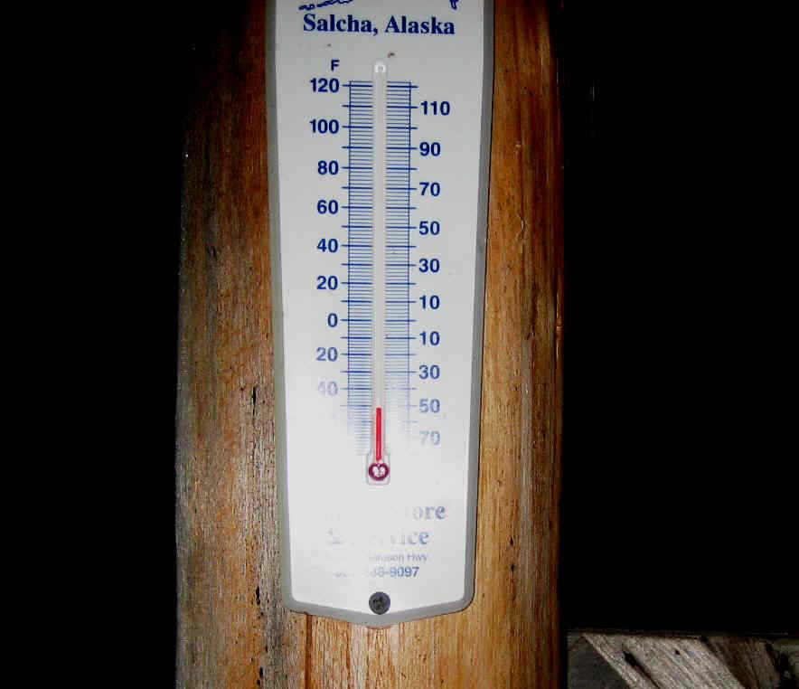 | Home  Sweet  Home

Community Survey #2

Highway improvements
*******
Alaska Railroad
Northern rail extension

